HUMAN TRAFFICKING:
ORGAN PILLAGING IN CHINA
Hon. David Kilgour, J.D., for International Coalition
to End Organ Abuse in China,
To Training Session of Ottawa Coalition to End Human Trafficking,
Overbrook Community Centre
Ottawa
12 June 2018

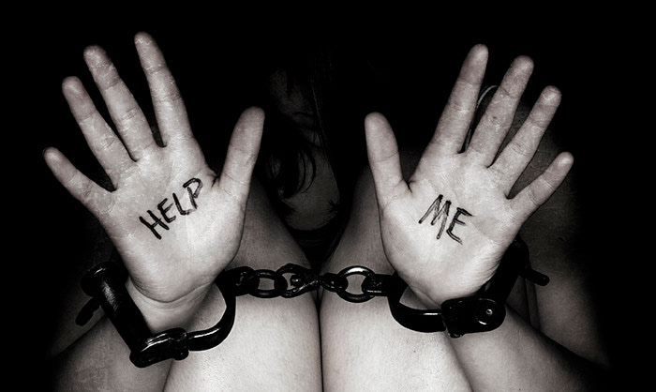
Human-trafficking is an appalling feature of modern life; there are estimated to be more enslaved workers in various sectors today than at any other time in recorded history. The reasons include a lack of general awareness, poor data, weak legal systems and insufficient resources. Most lacking of all is a co-ordinated international campaign. Responsible national governments worldwide need to act together in a unified response.
I congratulate you on your website commitment (www.endhumantrafficking.ca) “to creating and sustaining a continuum among organizations, service providers, community members and volunteers that provides a uniform, timely and appropriate response to those who seek access to supports, services and resources because they have been affected by human trafficking, irrespective of their age, gender, religion, sexual orientation and ethno-cultural background. Irrespective of the avenue through which a person seeks assistance, our commitment is to work together within and outside our network to ensure that the response is equally appropriate and effective.
BLOODY HARVEST
There is also the related scourge of organ pillaging/trafficking, which has targeted and victimized innocent people across China for almost twenty years.
In 2006, the Coalition to Investigate the Persecution of Falun Gong in China (CIPFG) asked David Matas and me as volunteers to investigate claims of organ trafficking from Falun Gong practitioners. We released two reports and a book, Bloody Harvest, and have continued to investigate (Our revised report is available in 18 languages from www.david-kilgour.com). We concluded that for 41,500 transplants done in the years 2000-2005 in China, the sourcing beyond any doubt was Falun Gong prisoners of conscience.
Our overall conclusion was that there “continues today to be large-scale organ seizures from unwilling Falun Gong practitioners (…) Their vital organs, including kidneys, livers, corneas and hearts, were seized involuntarily for sale at high prices, sometimes to foreigners, who normally face long waits for voluntary donations of such organs in their home countries”.
EVIDENCE
Here are two of the 18 kinds of evidence that led to our finding:

- Investigators made many calls to hospitals, detention centres and other facilities across China claiming to be relatives of patients needing transplants and asking if they had organs of Falun Gong for sale. We obtained on tape and then transcribed and translated admissions that approximately 15 such facilities across the country were then trafficking in Falun Gong organs.
- Falun Gong prisoners, who later got out of China, indicated that they were systematically blood-tested and organ-examined while in forced-labour camps across the country. Since they were tortured, this could not have been for their health, but was necessary for successful organ transplants and for building a bank of live “donors”.
THE SLAUGHTER
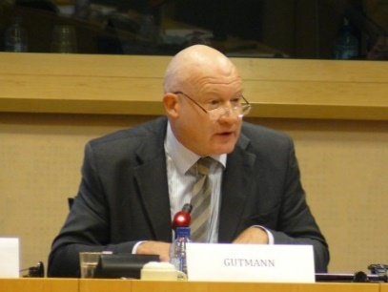  Ethan Gutmann | Nobel Peace Prize nominee and co-founder of the International Coalition to end Organ Abuse in China Ethan Gutmann’s 2014 book, The Slaughter, places the persecution of the Falun Gong, Tibetan, Uyghur, and Eastern Lightening Christian communities in context. He explains how he arrived at his “best estimate” that organs of 65,000 Falun Gong and “two to four thousand” Uyghurs, Tibetans and Christians were “harvested” in the 2000- 2008 period
The closing words of Slaughter are addressed to responsible governments, organizations and persons: “No Western entity possesses the moral authority to allow the (P)arty to impede the excavation of a crime against humanity in exchange for promises of medical reform. As a survival mechanism of our species, we must contextualize, evaluate, and ultimately learn from every human descent into mass murder … The critical thing is that there is a history. And only the victims’ families can absolve the (P)arty from its weight.”
MID-2016 UPDATE
Matas, Gutmann and I released an Update on our two books in June 2016 in Washington, Ottawa and Brussels (accessible from the International Coalition to End Organ Abuse in China at www.endorganpillaging.org ).

- It provides a thorough examination of the transplant programs of hundreds of hospitals across China, drawing on medical journals, hospital websites, and deleted websites found in archives. It analyzes hospital revenues, bed counts and utilization rates, surgical personnel, state funding and other factors.
- We conclude cautiously that a minimum of 60,000 transplants per year are being done across China as of mid-2016, not the approximately 10,000 the government claims. There is a very small pool of ‘volunteer donors’ plus a few thousand convicted prisoners. This means that about 150 persons daily are killed for their organs.
- We provide much evidence of a state-directed organ transplantation network, controlled through national policies and funding, and implicating both the military and civilian healthcare systems.
The party-state’s current narrative asserts that all transplantation organs since Jan 2015 are voluntarily provided through the semantical trick of reclassifying prisoner organs as “voluntary donations”.
Professionals who should know better, including the World Health Organization, the Transplantation Society (TTS) and the Pontifical Academy of Sciences, have accepted the party line, skipping over, as Louisa Greve of the International Coalition to End Organ Abuse in China puts it (www.endtransplantabuse.org ), “the admission that China’s billion-dollar transplant industry was built on prisoners’ organs”.
Last fall, after a screening of the Peabody award-winning film Human Harvest at a theatre in Boston’s Harvard Square, I stressed points made earlier by my colleague David Matas (http://endorganpillaging.org/party-profession-organ-transplant-abuse-china/):
- Mental health professionals globally faced the abuse of psychiatry in the Soviet Union and acted strongly against it. Today, international transplant professionals face the abuse of transplant surgery in China, but their responses differ.
- The global transplantation profession today can be broken into three groups.
  - The aware who have read the research and realize that what is going on in China with transplantations is mass killing of innocents and cover up. They react accordingly, distancing themselves from the Chinese transplant profession and encouraging others to do likewise.
  - The naive do not consider the research and argue that somehow doing so falls outside their area of responsibility. They hear research conclusions on the one hand and party-state propaganda on the other and draw no conclusions.
  - The foolish buy Chinese party-state propaganda. They parrot its line that the research demonstrating mass killing of innocents is based on rumour. They echo the Party line that the research is unverifiable, though it is both verifiable and verified. They repeat its claim that abuses are in the past, when they most certainly are not.
- The global transplant leadership (the World Health Organization (WHO), The Transplantation Society (TTS) and the Declaration of Istanbul Custodian Group (DICG)) does not have the time to read research into transplant abuse in China, or the grace to invite researchers to the events they help organize, but they might at least listen to what they themselves are saying.
- People in China, especially state officials, who deviate from the Party line get arrested. That is pervasive across all areas of policy, and not just something which happens in the transplantation field. They are released only if they undertake, after release, to conform to the Party line. There is no other basis for release, except for extreme illness. For foreign transplant leaders to take at face value what a released official says, without investigation or verification, means that they too are adopting the Party line.
- Outside China, organ sources are either dead (at least brain dead) before the sourcing or alive both before and afterwards. China is the only country in the world today where sources are killed by organ extraction, and where sources are alive before and dead afterwards.
There is an equation here of Chinese law and policy with practice, showing a lack of awareness that the law in China cannot be enforced against the Party, since it controls all aspects of the enforcement of the legal system… The four organizations (World Health Organization (WHO), the Vatican’s Pontifical Academy of Sciences (PAS), The Transplantation Society (TTS) and the Declaration of Istanbul Custodian Group (DICG)) are pleased that the Party says what they want to hear.
Beijing has no credible answers to the work of independent researchers who have demonstrated the mass killings of innocents. Given the scale of the transplantation industry in China, it is impossible to deny this research in any credible manner. Party propaganda, denying official data, pretending what is there is not there, can persuade only the gullible or the wilfully blind. One can only hope that a willingness to confront the truth about China will prevail generally in the transplantation profession before many more innocents are killed for their organs.

FORCED LABOUR CAMPS
David Matas and I visited a dozen countries to interview Falun Gong practitioners who had managed to leave both the camps and China. These prisoners of conscience have been the major source of organs since 2001 across China. They told us of working in appalling conditions for up to sixteen hours daily in these camps with no pay and little food, crowded sleeping conditions and torture. Inmates make a range of export consumer products as subcontractors to multinational companies. This constitutes gross corporate irresponsibility and a violation of WTO rules, calling for an effective response by all trading partners of China.

CONCLUSION
James Mann, author of China Fantasy and former Beijing bureau chief of the Los Angeles Times: “…Democratic governments around the world need to collaborate more often in condemning Chinese repression — not just in private meetings but in public as well…Why should there be a one-way street in which Chinese leaders send their own children to America’s best schools, while locking up lawyers at home? The Chinese regime is not going to open up because of our trade with it…”
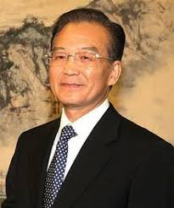 | Premier Wen Jiao-bao noted before leaving office, “Without the success of political structural reform, it is impossible for us to fully institute economic structural reform. The gains we have made…may be lost…and such a historical tragedy as the Cultural Revolution may happen again.”
Governments and business everywhere should examine why they are supporting the violation of so many basic human rights in order to increase trade and investment with China. It has resulted mostly in national jobs being outsourced to China and continuous increases in bi-lateral trade and investment deficits. Are we so focused on access to inexpensive consumer goods that we ignore the human, social and natural environment costs paid by abused Chinese nationals to produce them?
A first step in a better direction by Canadians is to end “organ tourism” to China by Canadians now. Ponder the reality that even if only 60,000 transplants per year are now done across China it means about 150 persons per day on average are being killed for their organs. Permit me to invite all of you to join our International Coalition against Organ Abuse in China, which you can do easily at www.endorganpillaging.org .

Thank you.

